PERSONAL ASSISTANCE FOR SENIORS WHO ARE SELF RELIANT

|  |  |
| --- | --- |
| Date | 02 November 2022 |
| Team ID | PNT2022TMID26841 |
| Project | HAZARDOUS AREA MONITORING FOR  INDUSTRIAL PLANT POWERED BY IOT |

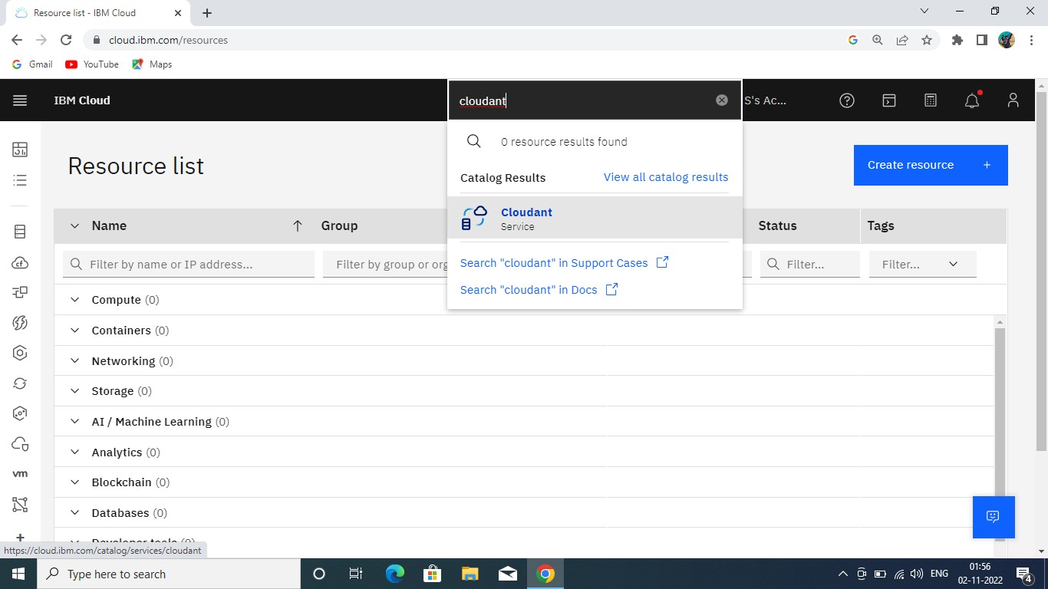CLOUDANT DB:

